1. Goto url: which contains public soap apis

<https://documenter.getpostman.com/view/8854915/Szf26WHn#96a53688-6305-45be-ab8b-ca1d1c88f830>

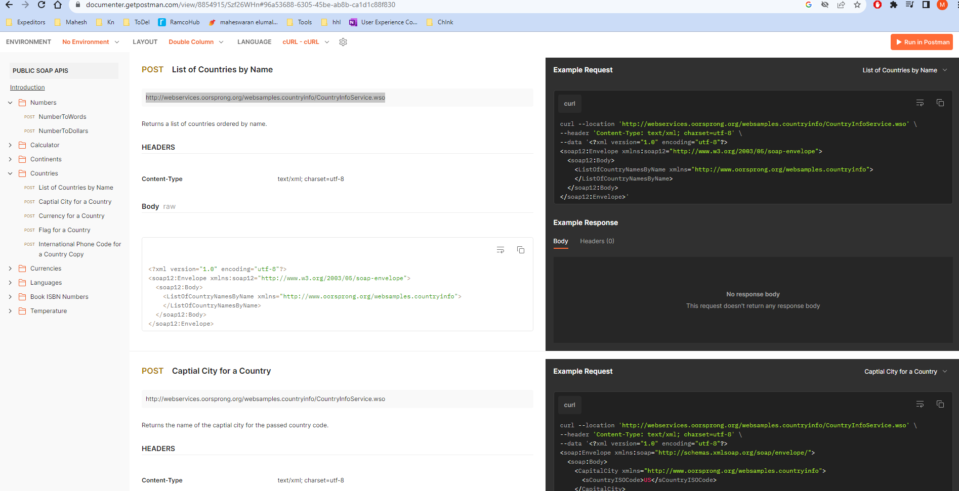

1. Copy the url: <http://webservices.oorsprong.org/websamples.countryinfo/CountryInfoService.wso>

1. Also copy the body

1. In postman, goto body,, paste the body text, select raw and type of text, chose as xml
2. Upon sending the request, we will get the below response

1. Now in sample api page, we can see content type as below:

1. Now change content-type to text/xml and we will get the response

